# Sites:

1. Open data site:
2. Server: gis-cogmap2
3. Rest Service Directory : <https://maps.garlandtx.gov/arcgis/rest/services/OpenData>
4. ArcGIS Online: <http://garland.maps.arcgis.com/home/content.html>

# Publish map services:

**Notes:**

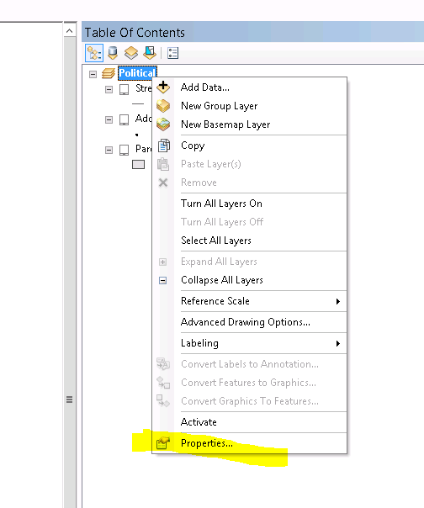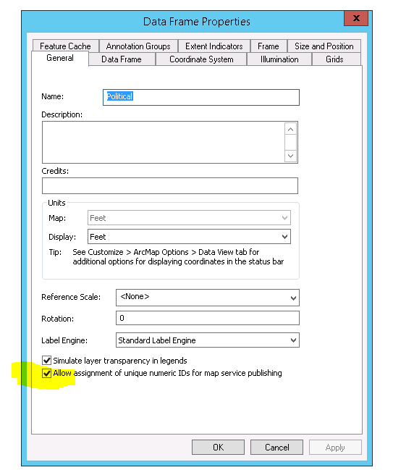

# Add map services to open data:

**Notes: use https instead of http.**

1. Get rest service url (**https**://maps.garlandtx.gov/arcgis/rest/services/OpenData/BaseLayers/MapServer/4)

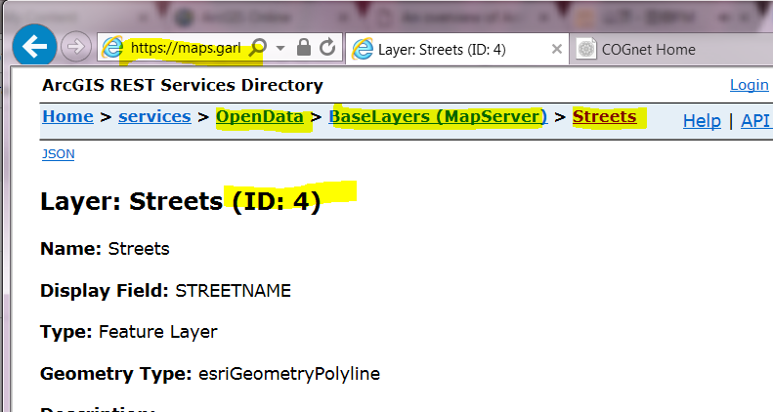

1. Open ArcGIS Online, login as [gis@garlandtx.gov](mailto:gis@garlandtx.gov)

* My Content 🡪 OpenDataService (folder) 🡪 Add Item 🡪From Web

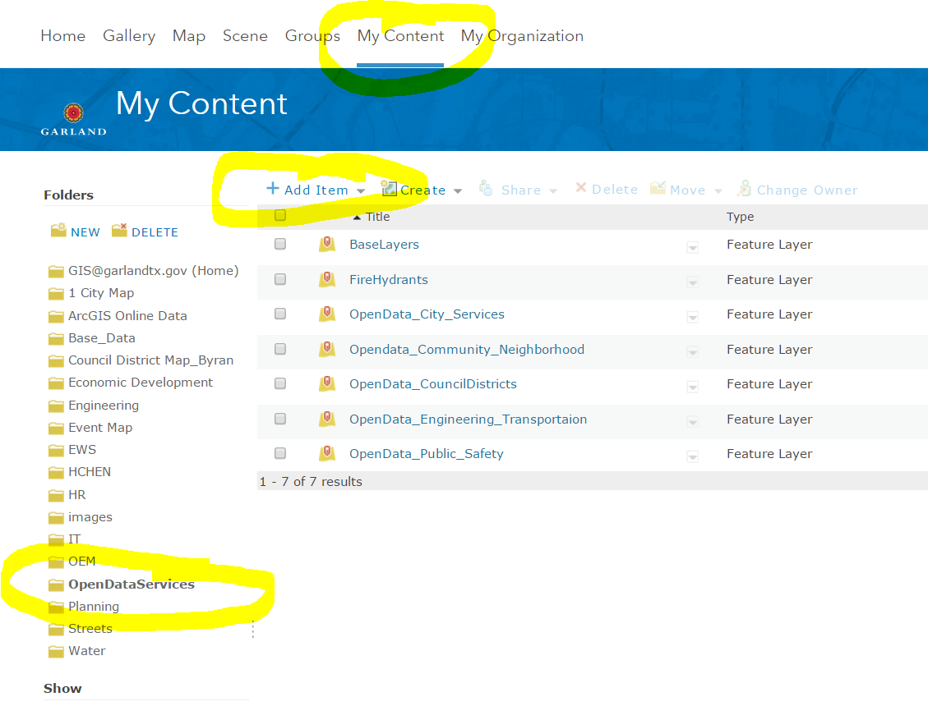

1. Add the url

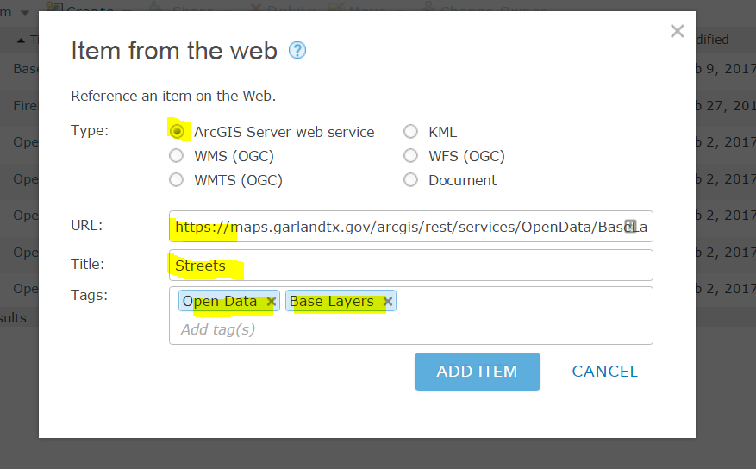

BaseLayers in the tags will need to match the “Data Categories” in our open data site:

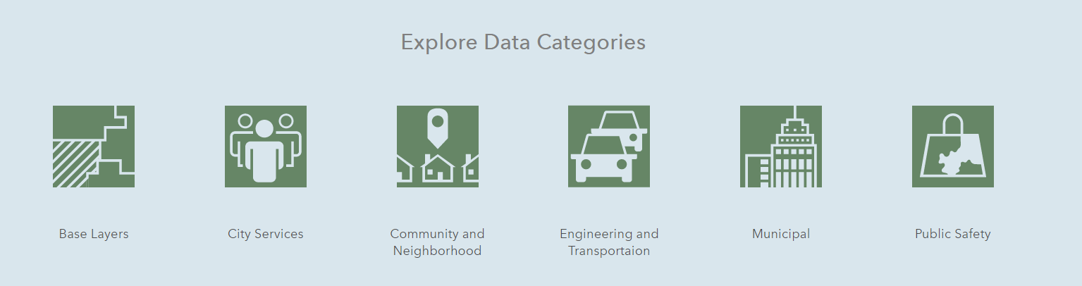

1. Share

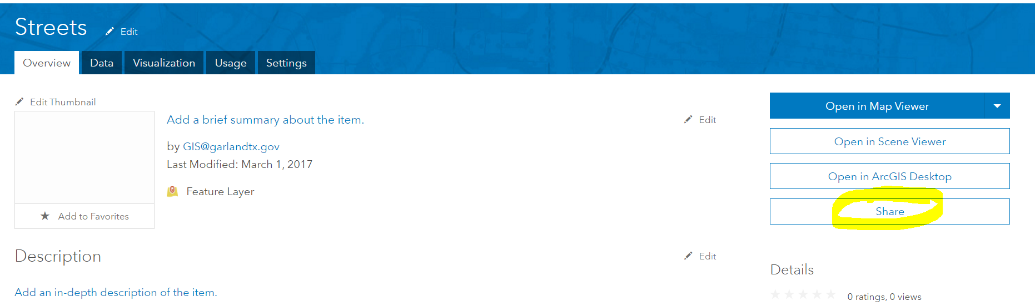 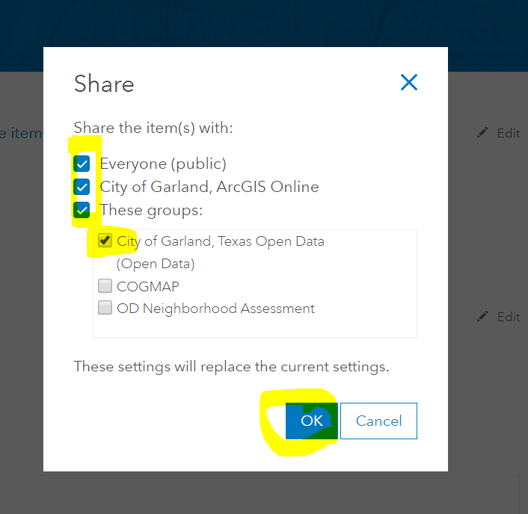

DONE!